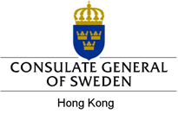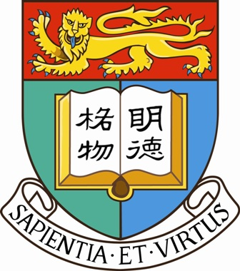

Seminar
Human Trafficking: Regional and
International Perspectives

Monday, 26 May 2008
1pm-3pm
Council Chamber, 8/F Meng Wah Complex, HKU

Anders Oljelund
Former Ambassador for International Cooperation against Trafficking in Human Beings
Ministry of Foreign Affairs, Sweden
Ingela Klinteberg
District Chief Prosecutor, Sweden

Karen Joe Laidler
Director, Centre for Criminology, HKU
Mr. Anders Oljelund was before his retirement the ambassador for international cooperation against trafficking in human beings at the Ministry of Foreign Affairs of Sweden. He has previously held posts as Sweden’s Ambassador to Belgium, Head of the Swedish NATO delegation in Brussels, and Head of the Department for Global Development at the Ministry for Foreign Affairs. Mr. Oljelund has also served in Kinshasa, Rome and Dar es Salaam. In this seminar he will talk about Swedish views on trade in human beings from an international perspective.

Ms. Ingela Klintberg is a District Chief Prosecutor in Sweden and expert on the trafficking issue. As a national expert on trafficking in human beings she is a member of the Network of Prosecutors against Trafficking in Human Beings among the Baltic Sea States and has a longstanding international experience as a speaker on different international events. In this seminar she will talk about Swedish law enforcement in combating trafficking, the historical review, laws, methods and international cooperation.

Dr. Karen Joe Laidler is Professor in the Department of Sociology and Director of the Centre for Criminology at the University of Hong Kong. She is a member of a CCPL research team led by Robyn Emerton examining the problem of human trafficking in Hong Kong and neighbouring jurisdictions. She will present some of her team’s research findings.

Please visit the CCPL website at www.hku.hk/ccpl/ for details and registration.
Admission is free. For enquiries: please contact Flora Leung at 2859 2941 or fkleung@hku.hk.

The Centre for Comparative and Public Law and the
Centre for Criminology, the University of Hong Kong

